**Project**

**On**

**Prevalence and determinants of diarrhea among children aged under 5 years in Bangladesh**



**MD RAZIBUL ISLAM**

**ROLL: 07**

**BATCH: 046**

**COURSE TITLE: PROJECT REPORT**

**UNIVERSITY OF BARISHAL**

**BARISHAL- 8254, BANGLADESH.**

# Acknowledgement

With the name of Allah, the Most Gracious and Merciful, I embark on expressing my profound gratitude to those who have played pivotal roles in the completion of this study. To my beloved parents and family members, their unwavering support has been my source of strength at every step of this journey. Their encouragement fueled my determination to achieve.

I extend my sincerest appreciation to my esteemed research supervisor, Mansura Begum, Assistant Professor at the Department of Statistics, Jagannath University. Her invaluable guidance, unwavering support, and scholarly insights have been instrumental in shaping this research endeavor. Without her mentorship, this study would not have reached its fruition.

# Abstract

This study aimed to estimate the prevalence of childhood diarrheal diseases (CDDs) and also to determine the factors associated with these conditions at the population level in Bangladesh.

The study entailed an analysis of nationally representative cross-sectional secondary data from the most recent Bangladesh Demography and Health Survey (BDHS) data conducted in 2017-18. A total of 412 children < 5 years old for CDDs during the survey from mothers aged between 15 to 49 years are the participants of this study. In the univariate and bivariate analysis, Pearson Chi-square test has been used to test the significance.

The overall prevalence of CDD among children < 5 years old was found to be 4.91%. Younger children were more likely to develop both CDDs compared to their older counterparts.

**Keywords**: Childhood diarrhea, Prevalence, BDHS, Bangladesh.

**Table of contents**

1. **Acknowledgement……………………………………………………….2**
2. **Abstract………………………...………………………………………..2**
3. **Introduction…………………...………………………………………...4**
   1. Background**………………………………………………………..4**
   2. Rational of the study...**…………………………………………….4**
   3. Objectives of the study**……………………………...…………….4**
4. **Literature Review………………………………………...…………….5**
5. **Methodology…………………………………………………………….5**
   1. Data source**………………………………………………………..5**
   2. Research design**……………………………………………………5**
   3. Sampling**…………………………………………………………..5**
   4. Sample size**………………………………………………………..6**
   5. Variable specification**……………………………………………..6**
      1. Response variable**………………………………………………..6**
      2. Explanatory variable**……………………………………………..6**
   6. Statistical methods**………………………………………………..9**
      1. Univariate analysis**…………………………...………………….9**
      2. Bivariate analysis**………………………………………...............9**
6. **Result and discussion……………………...……………………………9**
   1. Univariate analysis**………………………...………………………9**
   2. Bivariate analysis**………………………………………………...12**

**7. Month-wise Total Sales Report(Excel)………………………………..18**

1. **Conclusion…………………………...……………………………….. 22**
   1. Conclusion**……………………………………………………… 22**
   2. Recommendations**……………...………………………………..23**
   3. Strengths and limitations of this study **………...………………..23**
2. **Reference………...…………………………………………………….23**

**Introduction**

## Background

Protecting the health and wellbeing of children is a crucial component of public health and global health targets. This is exemplified in the ended Millennium Development Goals (MDGs) and the fairly new Sustainable Development Goals (SDGs), especially SDG 3.2 which seeks to reduce under-five mortality to as low as 25 per 1000 live births by 2030. Nonetheless, diarrhea remains a major cause of morbidity and mortality among children under-five worldwide, with diarrheal disease constituting about 9% of under-five mortality (UNICEF, 2016).

## Rational of the study

Diarrhea remains a leading cause of childhood mortality in developing countries. In an effort to inform strategic planning for prevention and management of diarrheal illnesses, the Global Enteric Multicenter Study (GEMS) was designed to elucidate the etiology and consequences of moderateto-severe diarrheal disease (MSD) among children 0–59 months of age residing in South Asia and sub-Saharan Africa, where more than 80% of the deaths occur. Seven field sites located in countries with moderate to high child mortality were selected to participate in GEMS, including Mirzapur, Bangladesh. Although Bangladesh has enjoyed remarkable gains in economic

**3.2Objectives of the study**

Diarrhea is a major public health problem in low- and middle-income countries, including Bangladesh. Of the different spectrums of diarrheal diseases, cholera occurs every year, causing outbreaks and epidemics following a biannual seasonal pattern. Hence, the aim of this study is

1. To investigate the prevalence of CDD.
2. To determine the factors associated with the age of children under 5 years.
3. To identify the effects of the disease.
4. To obtain a solution for reducing the likelihood of disease occurrence.

# Literature review

The four major infectious diseases that cause death in children under the age of 5 are [pneumonia](https://www.sciencedirect.com/topics/engineering/pneumoniae), diarrheal diseases, malaria and [measles](https://www.sciencedirect.com/topics/medicine-and-dentistry/measles) .However, 25% and 31% of the overall diarrheal burden has been attributed to diarrheal among children below the age of 5 in Africa and [Asia](https://www.sciencedirect.com/topics/earth-and-planetary-sciences/asia) respectively ([Walker et al., 2012](https://www.sciencedirect.com/science/article/pii/S2405844020305351)), especially Sub-Saharan Africa which has the highest death rate. Despite the global decline in the diarrhea mortality rate from 11% in 2010 to 9% in 2015, it is still the second cause of mortality among children under five years of age ([Liu et al., 2012](https://www.sciencedirect.com/science/article/pii/S2405844020305351); [Liu et al., 2016a](https://www.sciencedirect.com/science/article/pii/S2405844020305351), [Liu et al., 2016b](https://www.sciencedirect.com/science/article/pii/S2405844020305351)).

# Methodology

## Data Source

In this study, the latest Bangladesh demographic and health survey (BDHS) data 2017-18 was used which is the eighth national survey conducted by the National Institute of Population Research and Training (NIPORT) of Health Education and Family Welfare Division of the Ministry of Health and Family Welfare under Training, Research and Development operational plan of 4th HPNSP (Health Population and Nutrition Sector Program).

## Research Design

The BDHS 2017-18 is a nationally representative cross-sectional household survey data, covering all the 8 administrative divisions of Bangladesh. The

survey used a list of enumeration areas (EAs) from the 2011 Population and Housing Census of the People’s Republic of Bangladesh, provided by the Bangladesh Bureau of Statistics (BBS), as a sampling frame (BBS 2011). The primary sampling unit (PSU) of the survey is an EA with an average of about 120 households.

## Sampling:

The survey is based on a two-stage stratified sample of households. In the first stage, 675 EAs (250 in urban areas and 425 in rural areas) were selected with probability proportional to EA size. The sample in that stage was drawn by BBS, following the specifications provided by ICF that include cluster allocation and instructions on sample selection. A complete household listing operation was then carried out in all selected EAs to provide a sampling frame for the second-stage selection of households. In the second stage of sampling, a systematic sample of an average of 30 households per EA was selected to provide statistically reliable estimates of key demographic and health variables for the country as a whole, for urban and rural areas separately, and for each of the eight divisions. Based on this design, 20,250 residential households were selected. Completed interviews were expected from about 20,100 ever-married women age 15-49.

## Sample size

For this study out of 8398 children 412 under age 5 who have diarrhea have been taken into account from both rural and urban areas.

## Variable specification

### Response variable

In this project the event of interest is diarrhea affected child under age 5. In the recent years it has become a bigger problem among children aged 0-5 years to

have diarrheal death. About 4.9% children suffer from diarrhea for different causes. Therefore, the response variable is number of children under age 5.

### Explanatory variable

The table below shows all the explanatory variables with categories.

**5.5.2.1: List of explanatory variables with their categories**

|  |  |  |
| --- | --- | --- |
| variable |  | category |
| Gender of child | • | Male |
|  | • | Female |
| Division | • | Barisal |
|  | • | Chittagong |
|  | • | Dhaka |
|  | • | Khulna |
|  | • | Mymensingh |
|  | • | Rajshahi |
|  | • | Rangpur |
|  | • | Sylhet |
| Type of place of residence | •  • | Urban Rural |
| Mother's educational level | •  • | No education Primary |
|  | • | Secondary |
|  | • | Higher |
| Father's educational level | •  • | No education Primary |
|  | • | Secondary |
|  | • | Higher |
| Mother's occupation | •  • | Not working  Professional/technical/managerial |
|  | • | Sales |

|  |  |  |
| --- | --- | --- |
|  | • | Agricultural - employee |
|  | • | Household and domestic |
|  | • | Services |
|  | • | Skilled manual |
| Father's occupation | •  • | Did not work  Professional/technical/managerial |
|  | • | Sales |
|  | • | Agricultural - self employed |
|  | • | Agricultural - employee |
|  | • | Services |
|  | • | Skilled manual |
|  | • | Unskilled manual |
|  | • | Don't know |
| Wealth index | • | Poorest |
|  | • | Poorer |
|  | • | Middle |
|  | • | Richer |
|  | • | Richest |
| Source of  drinking water | •  • | Piped into dwelling Piped to yard/plot |
|  | • | Piped to neighbor |
|  | • | Public tap/standpipe |
|  | • | Tube well or borehole |
|  | • | Unprotected well |
|  | • | River/dam/lake/ponds/stream/canal/irrigation channel |
|  | • | Rainwater |
|  | • | Not a dejure resident |
| Had plain water | • | No |
|  | • | Yes |
| Had tinned, powdered or | •  • | No  Yes |
| fresh milk |  |  |
| Had other liquid | • | No |
|  | • | Yes |
| Had baby  formula | •  • | No  Yes |
| Had fruits | • | No |
|  | • | Yes |
| Had anything other than breast milk | •  • | No  Yes |

## Statistical method

### Univariate analysis

Univariate analysis is a statistical method used to analyze data with only one variable. It's often the simplest form of data analysis and involves examining the distribution and summary statistics of that single variable. Univariate analysis helps in understanding the characteristics of the variable under study, such as its central tendency, dispersion, shape of distribution, and presence of outliers. Univariate data does not answer research questions about relationships between variables, but rather it is used to describe one characteristic or attribute that varies from observation to observation.

### Bivariate analysis

Bivariate analysis is a statistical method used to analyze the relationship between two variables. Unlike univariate analysis, which focuses on a single variable, bivariate analysis examines how the value of one variable changes concerning the value of another variable. It helps in understanding the association, correlation, or causality between two variables. For bivariate analysis Pearson chi-square test is used in this study.

# Result and discussion

## Univariate analysis

Here percentage frequency and different kinds of graphs and charts is used for univariate analysis of the response variables.

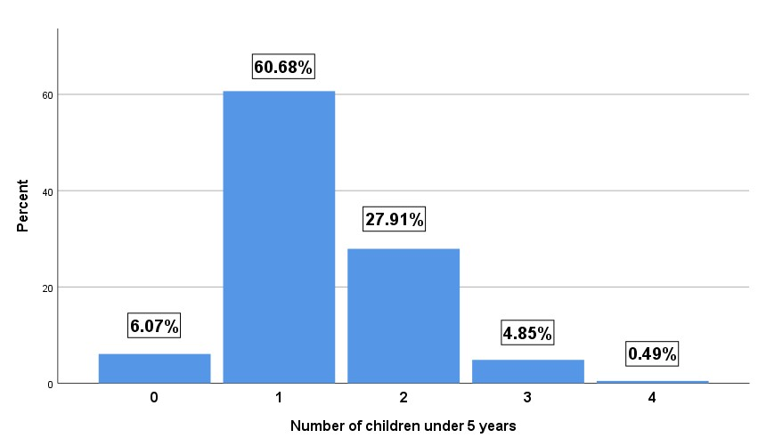

**Figure 6.1.1: Bar chart of Number of children under age 5**

**Number of children under age 5:**  From the figure, it appears that the majority of children experienced diarrhea between the ages of 1-3 years. Specifically, the highest ratio of diarrhea cases occurred at age 1 year, accounting for approximately 60.68% of cases. Conversely, the lowest ratio, around 0.49%, was observed at age 4 year. This suggests that there is a peak in the occurrence of diarrhea cases among children between the ages 1-3 years, with a decline in incidence as children reach older ages.

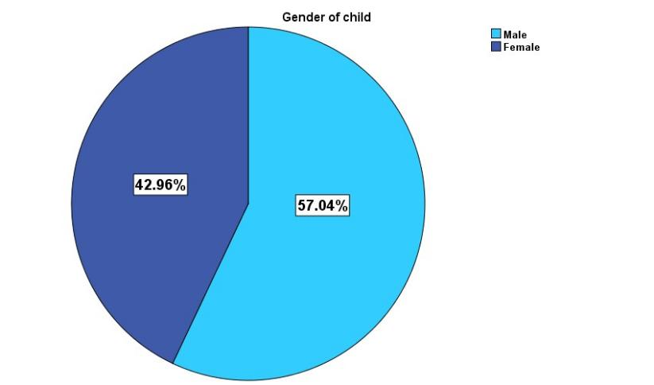

**Figure 6.1.2: Pie chart of Gender of child**

**Gender of child:** According to the data presented in the pie chart, approximately 57.04% of the children suffering from diarrhea are male, while 42.96% are female. This indicates that a higher percentage of male children are affected by diarrhea compared to female children.

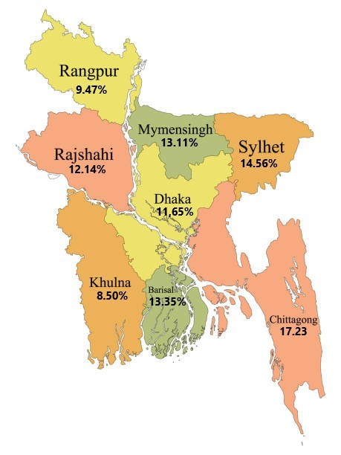

**Figure 6.1.3: Map chart of Division**

**Division:** Based on the observation from Figure 6.1.3, it appears that the Chittagong division has the highest percentage of children suffering from diarrhea, accounting for 17.23% of cases. Following Chittagong, Sylhet division has 14.56% and Barisal division has 13.35% of children suffering from diarrhea. On the other hand, Khulna division has the lowest percentage of children suffering from diarrhea, with 8.50% of cases, followed by Rangpur division with 9.47%.

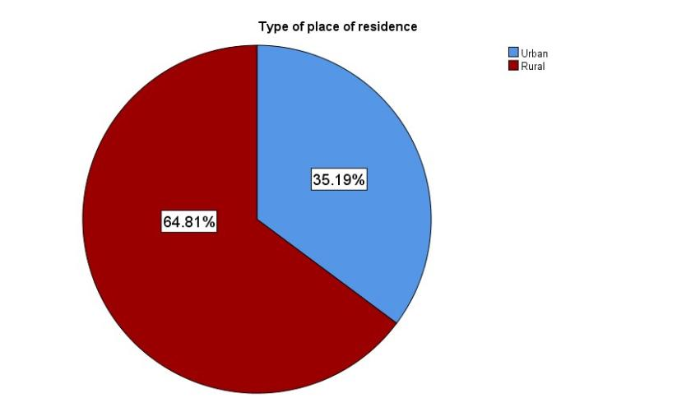

**Figure 6.1.4: Pie chart of Type of place of residence**

## Bivariate analysis

**Number of children under age 5 vs. division:**

**Table 6.2.2: Association between Number of children under age 5 and Division**

|  |  |  |  |  |  |  |  |
| --- | --- | --- | --- | --- | --- | --- | --- |
|  |  | **Number of children under ag** | | | | **e 5** | **P-**  **value** |
| **0** | **1** | **2** | **3** | **4** |
| **Division** | **Barisal** | **1.0%** | **8.0%** | **4.1%** | **0.2%** |  | **0.047** |
| **Chittagong** | **1.0%** | **8.5%** | **6.6%** | **1.0%** | **0.2%** |
| **Dhaka** | **0.7%** | **8.3%** | **1.9%** | **0.7%** |  |
| **Khulna** | **0.2%** | **5.8%** | **2.4%** |  |  |
| **Mymensingh** | **1.5%** | **7.8%** | **3.6%** | **0.2%** |  |
| **Rajshahi** | **1.5%** | **8.3%** | **2.4%** |  |  |
| **Rangpur** |  | **6.6%** | **2.2%** | **0.7%** |  |
| **Sylhet** | **0.2%** | **7.5%** | **4.6%** | **1.9%** | **0.2%** |

From the above table 6.2.2, it can be seen that the majority of children who have diarrhea fall within the age range of 1-2 years across all divisions. Chittagong, Dhaka and Rajshahi divisions have the highest occurrence of diarrhea with 8.5%, 8.3%, and 8.3% respectively at 1 years of age. As children grow older, the occurrence of diarrhea decreases. In most divisions, children tend not to suffer from diarrhea after 2 years of age. The lowest occurrence of diarrhea is observed in different divisions at various age ranges: Khulna division: 0.2% at less than 1 year, Barisal division: 0.2% at 3 years of age, Chittagong division: 0.2% at 4 years of age, Mymensingh division: 0.2% at 3 years of age, Sylhet:

0.2% at 0 and 4 years of age. This suggests that diarrhea is most prevalent in children aged 1-3 years across divisions in the given data, with decreasing occurrence as children get older.

The above p-value 0.047 suggests that there is a statistically significant association between Number of children under age 5 and Division.

**Number of children under age 5 vs. Type of place of residence:**

**Table 6.2.3: Association between Number of children under age 5 and Type of place of residence**

|  |  |  |  |  |  |  |  |
| --- | --- | --- | --- | --- | --- | --- | --- |
|  |  | **Number of children under age 5** | | | | | **Pvalue** |
| **0** | **1** | **2** | **3** | **4** |
| **Type of place of residence** | **Urban** | **1.2%** | **21.6%**  **39.1%** | **9.7%** | **2.7%** |  | **0.132** |
| **Rural** | **4.9%** | **18.2%** | **2.2%** | **0.5%** |

Based on the information from Table 6.2.3, rural area children are more affected by diarrhea compared to urban area children. Young children are more susceptible to diarrhea in both rural and urban areas. In rural areas, the prevalence of diarrhea is particularly high, with 39.1% of children experiencing it at 1 years of age and 18.2% at 2 years of age and lowest with 0.5% at 4 years of age. In urban areas, the lowest occurrence is 1.2% at 0 years of age. In urban areas, the highest occurrence is 21.6% at 1 years of age. This data suggests that diarrhea affects a higher proportion of children in rural areas, especially at younger ages, compared to urban areas. However, the prevalence decreases as children get older in both rural and urban areas.

However, the p-value of 0.132 indicates that there is no statistically significant association between Number of children under age 5 and Type of place of residence.

**Number of children under age 5 vs. Mother’s education level:**

**Table 6.2.4: Association between Number of children under age 5 and Mother's educational level**

|  |  |  |  |  |  |  |  |
| --- | --- | --- | --- | --- | --- | --- | --- |
|  |  | **Number of children under age 5** | | | | | **Pvalue** |
| **0** | **1** | **2** | **3** | **4** |
| **Mother's educational level** | **No education** |  | **5.6%** | **2.4%** | **0.2%** |  | **0.361** |
| **Primary** | **1.2%** | **16.7%**  **29.6%** | **9.2%** | **1.7%** | **0.5%** |
| **Secondary** | **3.4%** | **11.2%** | **1.9%** |  |
| **Higher** | **1.5%** | **8.7%** | **5.1%** | **1.0%** |  |

The data from Table 6.2.4 reveals that at 1 years of age, the highest incidence of diarrhea is evident among children whose mothers have attained secondary education, standing at 29.6% followed by 11.2% at 2 years of age, while the lowest occurrence is markedly lower at 0.2% among children of age 3 whose mothers have no education. Similarly, this trend persists across subsequent age brackets, with children of mothers with secondary education consistently exhibiting higher rates of diarrhea compared to those with no education. For instance, at 1 years of age, 16.7% of children with mothers having primary education suffer from diarrhea, contrasting with 5.6% among those whose mothers lack formal education. As children age, the prevalence of diarrhea gradually declines.

The above p-value 0.361 indicates that there is no statistically significant association between Number of children under age 5 and Mother's educational level.

**Number of children under age 5 vs. Father’s education level:**

**Table 6.2.5: Association between Number of children under age 5 and Father's education level**

|  |  |  |  |  |  |  |  |
| --- | --- | --- | --- | --- | --- | --- | --- |
|  |  | **Number of children under age 5** | | | | | **Pvalue** |
| **0** | **1** | **2** | **3** | **4** |
| **Father's education level** | **No education** | **0.2%** | **7.8%** | **3.2%** |  |  | **0.031** |
| **Primary** | **1.2%** | **22.2% 11.7%** | | **2.2%** | **0.5%** |
| **Secondary** | **2.2%** | **22.0%** | **7.6%** | **1.0%** |  |
| **Higher** | **2.2%** | **9.0%** | **5.4%** | **1.7%** |  |

The data from Table 6.2.5 reveals that at 1 years of age, the highest incidence of diarrhea is evident among children whose fathers have attained primary education, standing at 22.2% followed by 22.0% whose father have attained secondary education, while the lowest occurrence is markedly lower at 0.2% among children whose fathers have no education. Similarly, with children of fathers with secondary and primary education consistently exhibiting higher rates of diarrhea compared to those with no education. For instance, at 2 years of age, 11.7% of children with fathers having primary education suffer from diarrhea, contrasting with 3.2% among those whose fathers lack formal education.

The above p-value 0.031 indicates that there is a statistically significant association between Number of children under age 5 and Father’s educational level.

**Number of children under age 5 vs. Mother’s occupation:**

**Table 6.2.6: Association between Number of children under age 5 vs. Mother’s occupation**

|  |  |  |  |  |  |  |  |
| --- | --- | --- | --- | --- | --- | --- | --- |
|  |  | **Number of children under age 5** | | | | | **Pvalue** |
| **0** | **1** | **2** | **3** | **4** |
| **Mother’s occupation** | **Not working** | **4.4%** | **35.0% 17.5%** | | **3.6%** | **0.5%** | **0.915** |
| **Professional/tech nical/managerial** |  | **1.5%** | **0.7%** |  |  |
| **Sales** |  | **1.0%** | **0.2%** | **0.2%** |  |
| **Agricultural – employee** | **0.7%** | **16.7%** | **7.5%** | **1.0%** |  |
| **Household and domestic** |  | **0.7%** |  |  |  |
| **Services** | **0.2%** | **1.0%** | **0.2%** |  |  |
| **Skilled manual** | **0.7%** | **4.9%** | **1.7%** |  |  |

The data in the above table shows that among children whose mothers are not working, the highest percentage suffering from diarrhea is found at age 1, with approximately 35.0% affected. Following this, at 3 years of age has the next highest percentage, with around 17.5% of children suffering from diarrhea. Among children aged 3 whose mothers are not working, approximately 3.6% are suffering from diarrhea. The data also suggests that as children grow older, regardless of their mother’s occupation, the percentage of children suffering from diarrhea reduces.

The above p-value 0.915 indicates that there is no statistically significant association between Number of children under age 5 and Mother’s occupation.

**Number of children under age 5 vs. Father’s occupation:**

**Table 6.2.7: Association between Number of children under age 5 vs. Father’s occupation**

|  |  |  |  |  |  |  |  |
| --- | --- | --- | --- | --- | --- | --- | --- |
|  |  | **Number of children under age 5** | | | | | **Pvalue** |
| **0** | **1** | **2** | **3** | **4** |
| **Father’s occupation** | **Did not work** | **0.2%** |  | **0.2%** | **0.2%** |  | **0.106** |
| **Professional/tech nical/managerial** |  | **4.4%** | **3.4%** | **0.7%** |  |
| **Sales** | **0.5%** | **9.2%** | **6.3%** | **1.7%** |  |
| **Agricultural – self employed** |  | **4.1%** | **1.5%** | **0.2%** |  |
| **Agricultural – employee** | **1.2%** | **8.3%** | **2.2%** |  | **0.2%** |
| **Services** | **0.7%** | **9.2%** | **2.7%** | **0.7%** |  |
| **Skilled manual** | **3.4%** | **25.2% 11.4%** | | **1.2%** | **0.2%** |
| **Unskilled manual** |  | **0.2%** |  |  |  |
| **Don’t know** |  |  | **0.2%** |  |  |

The data in the above table shows that among children whose fathers are skilled manual, the highest percentage suffering from diarrhea is found at 2 years of age, with approximately 25.2% affected. Following this, at 3 years of age has the next highest percentage, with around 11.4% of children suffering from diarrhea. Among children aged 20-24 months whose fathers are in sales and services, approximately 9.2% are suffering from diarrhea. Children whose father is skilled manual are more suffering from diarrhea than father who doesn’t work.

The above p-value 0.106 indicates that there is no statistically significant association between Number of children under age 5 and Father’s occupation.

**Number of children under age 5 vs. Wealth index:**

**Table 6.2.8: Association between Number of children under age 5 and Wealth index**

|  |  |  |  |  |  |  |  |
| --- | --- | --- | --- | --- | --- | --- | --- |
|  |  | **Number of children under ag** | | | | **e 5** | **P-value** |
| **0** | **1** | **2** | **3** | **4** |
| **Wealth index** | **Poorest** | **1.2%** | **13.8%** | **6.3%** | **1.0%** |  | **0.974** |
| **Poorer** | **1.7%** | **12.1%** | **4.9%** | **0.7%** |  |
| **Middle** | **1.0%** | **13.1%** | **6.8%** | **1.0%** | **0.2%** |
| **Richer** | **1.2%** | **8.3%** | **4.6%** | **1.0%** |  |
| **Richest** | **1.0%** | **13.3%** | **5.3%** | **1.2%** | **0.2%** |

The data from Table 6.2.8 highlights that at the age of 1, children from the poorest families exhibit the highest occurrence of diarrhea, standing at 13.8%, followed by 13.3% from richest family, 13.1% from middle family and 12.1% from poorer family. At the age of 2, 6.3% children from poorest family, 4.9% from poorer family, 6.8% from middle family, 4.65 from richer family and 5.3% from richest family are suffering from diarrhea. The lowest occurrence was recorded at age 4 with 0.2% from middle and richest family.

The above p-value 0.974 indicates that there is no statistically significant association between Number of children under age and Wealth index.

**Number of children under age 5 vs. Source of drinking water:**

**Table 6.2.9: Association between Number of children under age 5 and Source of drinking water**

|  |  |  |  |  |  |  |  |
| --- | --- | --- | --- | --- | --- | --- | --- |
|  |  | **Number of children under age 5** | | | | | **Pvalue** |
| **0** | **1** | **2** | **3** | **4** |
| **Source of drinking water** | **Piped into dwelling** |  | **2.2% 0.2% 0.2%** | | |  | **0.000** |
| **Piped to yard/plot** |  | **1.0% 0.2%** | |  |  |
| **Piped to neighbor** |  | **0.2%** |  |  |  |
| **Public tap/standpipe** |  | **0.2%** |  |  |  |
| **Tube well or borehole** | **0.2%** | **53.6**  **%** | **26.9**  **%** | **4.6%** | **0.5%** |
| **Unprotected well** |  | **0.2%** |  |  |  |
| **River/dam/lake/po nds/stream/canal/ir rigation channel** |  | **0.7%** |  |  |  |
| **Rainwater** |  | **0.2%** |  |  |  |
| **Not a dejure resident** | **5.8%** | **2.2%** | **0.5%** |  |  |

The data presented in Table 6.2.9 reveals that children at 1 years of age whose source of drinking water is a tube well or borehole exhibit the highest prevalence of diarrhea, standing at 53.6% followed by 26.9% at age 2. Conversely, the lowest prevalence, recorded at 0.2%, is observed among children aged 0-3 years. The prevalence of diarrhea fluctuates across age groups and water sources, with notable occurrences at various intervals: 0.2% among children aged 0 or less years, 53.6% among those aged 1 year, 26.9% among those aged 2 year, 4.6% among those aged 3 year, 0.5% among those aged 3539 months, 1.2% among those aged 40-44 months, and 0.2% among those aged 4 year, all with a source of drinking water from tube wells or boreholes. This data underscores the critical role of water source sanitation in mitigating the risk of diarrhea among children, highlighting the importance of access to safe and clean drinking water, particularly during early childhood development stages.

The above p-value 0.000 indicates that there is a statistically significant association between Number of children under age and Source of drinking water.

# Month-wise Total Sales Report(Excel)

This report provides a detailed month-wise analysis of the company's total sales from January to December.

|  |  |
| --- | --- |
| **Month** | **Total Sales ($)** |
| **January** | 161,810.00 |
| **February** | 94,703.00 |
| **March** | 73,513.00 |
| **April** | 220,518.00 |
| **May** | 249,650.00 |
| **June** | 138,445.00 |
| **July** | 61,844.50 |
| **August** | 44,762.00 |
| **September** | 26,672.00 |
| **October** | 73,672.00 |
| **November** | 14,491.00 |
| **December** | 145,595.00 |
| **Total** | 1,305,675.50 |

Area-Wise Total Sales Report

This report provides an overview of total sales performance across different geographical areas for the period of January 2018 to December 2019.

|  |  |
| --- | --- |
| **Region** | **Total Sales (in USD)** |
| **Barishal** | $180,239.50 |
| **Chittagong** | $160,151.00 |
| **Dhaka** | $507,726.00 |
| **Khulna** | $454,634.00 |
| **Mymensingh** | $2,925.00 |
| **Total** | $1,305,675.50 |

Product Wise Total Sales Report

This report analyzes the total sales performance of various product categories for the period of January 2018 to December 2019.

|  |  |
| --- | --- |
| **Product** | **Total Sales (in USD)** |
| **Cell Phone** | $62,550.00 |
| **Desk** | $1,250.00 |
| **Home Theater** | $361,000.00 |
| **Television** | $857,768.00 |
| **Video Games** | $49,182.50 |
| **Total** | $1,331,750.50 |

# Conclusion

## conclusion

This project aims to investigate various factors associated with number of children under age 5 with diarrhea disease. In this project univariate analysis and bivariate analysis is used.

Univariate analysis reveals the following findings: The majority of the diarrhea disease in young children occurs at age 0-2 years which shows the need for immediate interventions. Diarrhea disease is more common in male child than female child where further investigation is needed. The highest number of child suffering diarrhea was recorded in Chittagong division, indicating the need for region-specific interventions. This disease was more common in rural areas, highlighting the necessity for targeted interventions and improved health access. The highest number of diarrhea disease occurred to mother with secondary education and father with primary education need further exploration. Majority of the disease occurred to mother with no education and father with skilled manual require further investigation. Most of the children suffering from the disease are from the poorest family group, highlighting the necessity for targeted interventions. Most of the children suffering from diarrhea disease are those who use tube well or borehole as source of drinking water, necessitating closer inspection. Most children who were given plain water suffer from the disease, highlighting the importance of drinking water source. Majority of the children suffering from diarrhea had tinned, powdered or fresh milk, other liquid, fruits, baby formula and anything other than breast milk.

## Recommendation

To prevent further cases of diarrhea among children, it's essential to implement a comprehensive approach that addresses multiple factors contributing to the disease. Here are some recommendations:

**Promote exclusive breastfeeding:** Encourage mothers to exclusively breastfeed their infants for the first six months of life. Breast milk provides essential nutrients and antibodies that help protect against diarrhea and other infections.

**Ensure access to safe drinking water:** Improve access to clean and safe drinking water sources, such as treated piped water or protected wells, to reduce the risk of waterborne diseases like diarrhea.

## Strengths and limitations of this study

* Here the most recent nationally representative data for this study is used which ensures that the findings are generalizable to children in Bangladesh.
* This study applied appropriate statistical analysis to assess the prevalence and analyze the associated factors concurrently for CDD. Therefore, this is a major contribution to CDD literature in Bangladesh.
* The data after 2017-18 is not currently available at hand, that’s why BDHS 2017-18 data had to be used in this study.
* Nevertheless, the use of secondary data that was based on cross-sectional design limits the analysis and the causal relationship cannot be ascertained between the outcome and independent variables.
* The information was self-reported by mothers thereby putting at risk of recall bias.

# Reference

1. WHO. Diarrheal disease [Internet]. [cited 2020 May 27]. Available from: [https://www.who.int/news-room/fact-sheets/detail/diarrhoealdisease](https://www.who.int/news-room/fact-sheets/detail/diarrhoeal-disease).[[Google Scholar](https://scholar.google.com/scholar?q=WHO.%20Diarrhoeal%20disease%20%5BInternet%5D.%20%5Bcited%202020%20May%2027%5D.%20Available%20from%3A%20https%3A%2F%2Fwww.who.int%2Fnews-room%2Ffact-sheets%2Fdetail%2Fdiarrhoeal-disease)]
2. M Naghavi, AA Abajobir, C Abbafati, KM Abbas, F AbdAllah, SF Abera, *et al.*

Global, regional, and national age-sex specific mortality for 264 causes of death, 1980–2016: a systematic analysis for the Global Burden of Disease Study 2016

The Lancet, 390 (10100) (2017), pp. 1151-1210

[ View PDF ] [[View in Scopus](https://www.scopus.com/inward/record.url?eid=2-s2.0-85031727040&partnerID=10&rel=R3.0.0)][ [Google Scholar](https://scholar.google.com/scholar_lookup?title=Global%2C%20regional%2C%20and%20national%20age-sex%20specific%20mortality%20for%20264%20causes%20of%20death%2C%2019802016%3A%20a%20systematic%20analysis%20for%20the%20Global%20Burden%20of%20Disease%20Study%202016&publication_year=2017&author=M%20Naghavi&author=AA%20Abajobir&author=C%20Abbafati&author=KM%20Abbas&author=F%20Abd-Allah&author=SF%20Abera)]

1. C Troeger, BF Blacker, IA Khalil, PC Rao, S Cao, SR Zimsen, *et al.* Estimates of the global, regional, and national morbidity, mortality, and aetiologies of diarrhoea in 195 countries: a systematic analysis for the

Global Burden of Disease Study 2016

The Lancet Infectious Diseases, 18 (11) (2018), pp. 1211-1228

[ View PDF ] [[View in Scopus](https://www.scopus.com/inward/record.url?eid=2-s2.0-85056480296&partnerID=10&rel=R3.0.0)][[Google Scholar](https://scholar.google.com/scholar_lookup?title=Estimates%20of%20the%20global%2C%20regional%2C%20and%20national%20morbidity%2C%20mortality%2C%20and%20aetiologies%20of%20diarrhoea%20in%20195%20countries%3A%20a%20systematic%20analysis%20for%20the%20Global%20Burden%20of%20Disease%20Study%202016&publication_year=2018&author=C%20Troeger&author=BF%20Blacker&author=IA%20Khalil&author=PC%20Rao&author=S%20Cao&author=SR%20Zimsen)]

1. IHME, GBD Compare. Institute for Health Metrics and Evaluation (IHME)

Global Burden of Disease Compare. Estimates of under-five deaths [Internet]

Institute for Health Metrics and Evaluation (2014)

[cited 2020 May 27]. Available from <http://www.healthdata.org/data-visualization/gbd-compare>

[[Google Scholar](https://scholar.google.com/scholar_lookup?title=Global%20Burden%20of%20Disease%20Compare.%20Estimates%20of%20under-five%20deaths%20Internet&publication_year=2014&author=IHME&author=GBD%20Compare.%20Institute%20for%20Health%20Metrics%20and%20Evaluation%20(IHME))]

1. United Nations. Transforming our world: the 2030 Agenda for

Sustainable Development .:. Sustainable Development Knowledge

Platform [Internet]. [cited 2020 May 27]. Available from: [https://sustainabledevelopment.un.org/post2015/transformingourwo rld](https://sustainabledevelopment.un.org/post2015/transformingourworld). [[Google Scholar](https://scholar.google.com/scholar?q=United%20Nations.%20Transforming%20our%20world%3A%20the%202030%20Agenda%20for%20Sustainable%20Development%20.%3A.%20Sustainable%20Development%20Knowledge%20Platform%20%5BInternet%5D.%20%5Bcited%202020%20May%2027%5D.%20Available%20from%3A%20https%3A%2F%2Fsustainabledevelopment.un.org%2Fpost2015%2Ftransformingourworld.)]

1. RA Mahumud, K Alam, AM Renzaho, AR Sarker, M Sultana, N Sheikh, *et al.*

Changes in inequality of childhood morbidity in Bangladesh 1993-2014: A decomposition analysis

PloS one, 14 (6) (2019) [[Google Scholar](https://scholar.google.com/scholar_lookup?title=Changes%20in%20inequality%20of%20childhood%20morbidity%20in%20Bangladesh%201993-2014%3A%20A%20decomposition%20analysis&publication_year=2019&author=RA%20Mahumud&author=K%20Alam&author=AM%20Renzaho&author=AR%20Sarker&author=M%20Sultana&author=N%20Sheikh)]